**Develop Website**

**Content and E-commerce in Drupal**

Develop a Drupal Website. The design is ready, you have to implement it from the templates in lower resolution. It's a page with content (journal articles) and e-commerce (selling books and courses). Basically with e-commerce, contact module, registration module, subscribe list box mail, google search, mail chimp module, google analytics, faq module, events, rotating banners, advertising modules. It's all described in the file templates and writing. Suggest and install a CRM.

Drupal version must be installed in Spanish. It’s important that the applicant has proven experience in Drupal. Estimated time: 25 days.

**About Magisterio**

Magisterio is a book publishing company based in Colombia that divides its operations in four main businesses: publisher, library, magazine and educational courses. The website is composed of this four main sections (from now described as *website section*) plus a home page. Each website section and the home page will be identified by its own logo and its own institutional color. When navigating through a content that belongs to a given section, the section template and colors should be used in many elements, such as links, some backgrounds and menus.

The website is basically a mix of articles and e-commerce website. For example, when reading an article we want to display a widget with related products to this article. This relation will be based on common tags between both. Additional to that, there are some other modules that should be developed or installed.

We provide below low-resolution images, so the designer can have an idea of what we want as design style.

Home section  
**anexo-0-home**

Editorial section  
**anexo-2-editorial-home**

Librería section  
**anexo-22-libreria-home**

Formación section  
**anexo-4-formacion-home**

# HTML &CSS

All HTML files should be in accordance to Google Webmasters Guideline, providing the optimized code for SEO. We want a responsive design, or any other solution that provides a good experience for tablets and mobiles users. HTML and CSS code also must comply to the best practices in speed page performance. Code should be clean and organized.

# HOSTING SOLUTION

We are in process of changing our hosting, so the developer can suggest his preferred hosting solution and we will choose together a hosting solution according to the budget available for that.

## Website Sections, colors and templates

**Home**

* Color: # D45680
* PDF - [?](http://www.magisterio.com.co/identidadvisual/logos/PDF/logo-libreria.pdf)
* Illustrator - [?](http://www.magisterio.com.co/identidadvisual/logos/Curvas/logo-libreria.ai)
* Header



**Librería** (Library)

* Color: #ED1A40
* PDF - <http://www.magisterio.com.co/identidadvisual/logos/PDF/logo-libreria.pdf>
* Illustrator - <http://www.magisterio.com.co/identidadvisual/logos/Curvas/logo-libreria.ai>
* Header
* 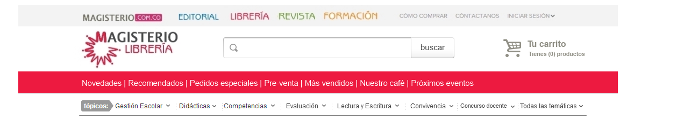

**Editorial** (Publisher)

* Color: #006FBA
* PDF - <http://www.magisterio.com.co/identidadvisual/logos/PDF/logo-editorial.pdf>
* Illustrator - <http://www.magisterio.com.co/identidadvisual/logos/Curvas/logo-editorial.ai>

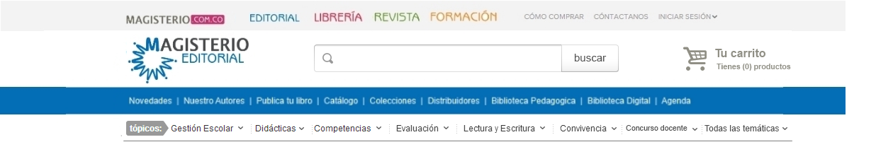

**Revista** (Magazine)

* Color: # 6E9A34
* PDF - <http://www.magisterio.com.co/identidadvisual/logos/PDF/logo-revista.pdf>
* Illustrator - <http://www.magisterio.com.co/identidadvisual/logos/Curvas/logo-revista.ai>

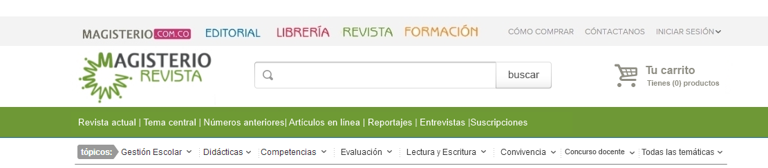

**Formación** (Education courses)

* Color: # F68B1F
* PDF - <http://www.magisterio.com.co/identidadvisual/logos/PDF/logo-formacion.pdf>
* Illustrator - <http://www.magisterio.com.co/identidadvisual/logos/Curvas/logo-formacion.ai>

Header



## menus

There are three kinds of menus available on each template.

### Home Template

**Main menu**

Unexpanded



Expanded

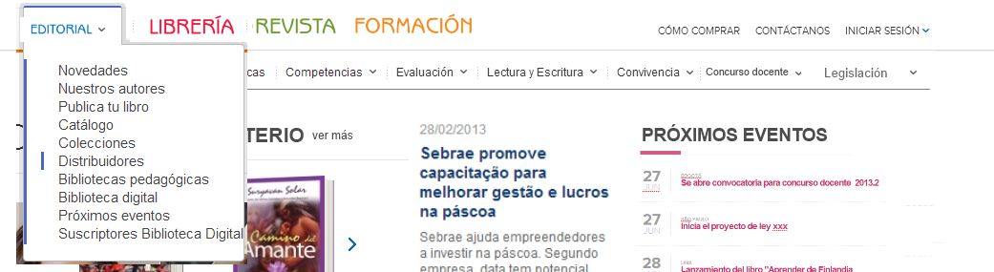

**Tags menu**Unexpanded  
   
  
Expanded  
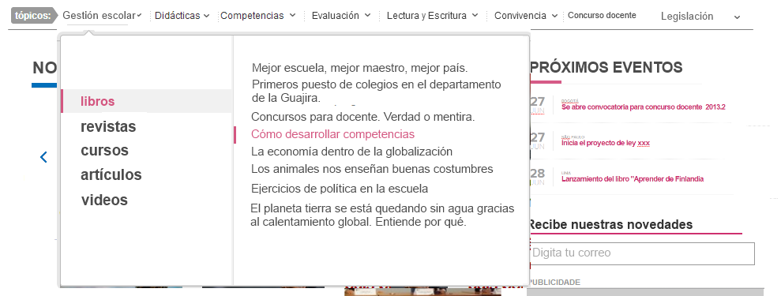

### Website sections template

**Main menu**Unexpanded  


**Website section menu**Unexpanded  


**Tags menu**Unexpanded  


Each website sections menu must be according to the website section colors. Admin must have the hability to add, remove, update any menu in the back-end.

## Articles

Articles are texts that can be published to any website section and can have its own category and tags.

**View. anexo-27-revista-contenido-articulo**

### Back-end

Users can add an article with the following fields: Mini-Title, Title, Subtitle, Author name, Published date, Article Text and images, Website section, Article Section, Category, Subcategory, Tags, Featured image, Thumbnail image, Private or Public.

### Front-end

The header displayed should be according to the website section the article belongs to. Also the widgets link colors, background colors should be according to the website section the article belongs to.

When reading an article (see image), users can see at the end of the text, related articles within common tags.

There should be also widgets that can be added to any page.

## Products

All products must belong to a website section. We must be able to set a tax individually to each product. Depending on what website section the product belongs to, the website section template must be used when viewing in front-end. Also, there are some types of products that will need some special fields like described below.

### Product Types

#### Books

There are 3 types of books that can be sold in the online library. Printed Books, E-books and Printed on demand books.

**anexo-22-libreria-home**

##### Types of books

###### Printed Books

* sku
* isbn
* publisher
* author
* title
* subtitle
* edition_year
* edition_number
* number_of_pages
* collection
* price
* discount
* description
* content_table
* category
* tags
* stock_quantity
* image
* image_thumbnail
* format_size
* format_cover
* weight
* creation_date
* last_update_date
* tax

###### E-books

* sku
* isbn
* publisher
* author
* title
* subtitle
* edition_year
* edition_number
* number_of_pages
* collection
* price
* discount
* description
* content_table
* category
* tags
* image
* image_thumbnail
* e-book_format
* creation_date
* last_update_date
* tax

###### Printed on demand books

* sku
* isbn
* publisher
* author
* title
* subtitle
* edition_year
* edition_number
* number_of_pages
* collection
* price
* discount
* description
* content_table
* category
* tags
* image
* image_thumbnail
* e-book_format
* creation_date
* last_update_date
* tax

#### Educational Courses and events

There are 2 types of courses that can be sold: **Online** and **Classroom courses**. And there are events that can be sold or not. Take a look at the model module “Entity Registration” that could be integration with “Drupal commerce”.

**Online**

**anexo-5-formacion-cursos presenciales**

**anexo-6-formacion-cursos presenciales-filtrar-por-categoria**

**anexo-9-formacion-pagina-interna-curso**

**Classroom courses**

**anexo-7-formacion-cursos virtuales-filtrar-por-categoria**

**anexo-9a-formacion-pagina-interna-curso-virtual**

**Events**

**anexo-9b-formacion-pagina-interna-evento**

**anexo-9c-formacion-pagina-interna-evento-free-pass**

##### Types of COURSES

###### ONLINE COURSES

* title
* subtitle
* category
* description
* content
* price
* discount
* available_positions
* tags
* image
* image_thumbnail
* address_location (generating a google map image)
* teacher_info
* course_date
* course_date_details
* creation_date
* last_update_date
* tax

###### CLASSROOM courses

* title
* subtitle
* category
* description
* content
* price
* discount
* available_positions
* tags
* image
* image_thumbnail
* teacher_info
* course_date
* course_date_details
* creation_date
* last_update_date
* tax

###### EVENTS

* title
* subtitle
* category
* description
* content
* price
* discount
* available_positions
* tags
* image
* image_thumbnail
* address_location (generating a google map image)
* teacher_info
* course_date
* course_date_details
* creation_date
* last_update_date
* tax

#### Magazines

Magazines are different from books but are displayed as the books.- **anexo-22-libreria-home**

##### Types of MAGAZINES

###### magazines

* sku
* issn
* publisher
* author
* title
* subtitle
* edition_year
* edition_number
* magazine_number
* number_of_pages
* price
* discount
* description
* content_table
* category
* tags
* stock_quantity
* image
* image_thumbnail
* format_size
* format_cover
* weight
* creation_date
* last_update_date
* tax

###### e-magazines

* sku
* issn
* publisher
* author
* title
* subtitle
* edition_number
* magazine_number
* number_of_pages
* price
* discount
* description
* category
* tags
* stock_quantity
* image
* image_thumbnail
* format_size
* weight
* creation_date
* last_update_date
* tax

### MODULES

###### contact module

anexo-1-contact-page

###### REGISTRATION MODULE

anexo-10-home-checkout-1

###### mail list subscribe box

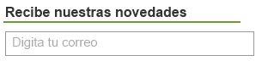

###### google search

anexo-28-search

anexo-29-search-filtro-por-categoria

anexo-30-search-ordenar-por



###### e-commerce

Drupal commerce or UberCart. Why?

**anexo-14-home-shopping-car-paso-1  
anexo-15- home-shopping-car-paso-1con-cupon-de-descuento  
anexo-16-home-shopping-car-paso2  
anexo-17-home-shopping-car-paso-3  
anexo-18-home-shopping-car-paso-3-enviar-para-otra-direccion  
anexo-19-home-shopping-car-paso-4  
anexo-21-home-shopping-car-paso-pas-4-como-funciona  
anexo-20-home-shopping-car-paso-final**

###### mailchimp module

Integrate de e-commerce module with mailchimp. (In that case only works with Ubercart?)

###### google analytics

###### FAQ MODULE

anexo-3-faq

anexo-3-faq-como-comprar

###### facebook box

###### Rotating banners

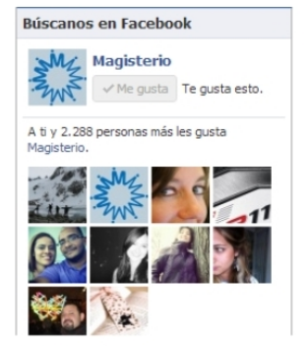

### Widgets

Product carrousel module.

* home- Name module: Novedades magisterio- Mostrar dos libros- flechas laterals para mostrar más
* En home- Name module: Novedades magisterio- Mostrar dos libros- flechas laterals para mostrar más
* En home editorial- Name module: Novedades magisterio- Mostrar cuatro libros- flechas laterals para mostrar más
* En home editorial- Name module: Recomendados- Mostrar cuatro libros- flechas laterals para mostrar más
* En home librería- Name module: Novedades- Mostrar cuatro libros- flechas laterals para mostrar más
* En home librería- Name module: Recomendados- Mostrar cuatro libros- flechas laterals para mostrar más
* En home librería- Name module: Pre-venta- Mostrar dos libros-
* En home librería- Name module: Más vendidos- Mostrar cuatro libros- flechas laterals para mostrar más

Next events

* Mostrar fecha (día y mes)
* Mostrar 4 eventos más próximos en fecha
* Mostrar sólo el título con enlace al evento

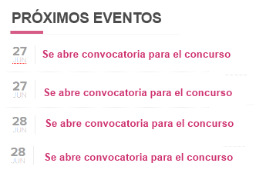

Publicidad

* Widget que se puedan despublicar
* Dos: 300 x 250 pixeles y de 300 x 100 pixeles
* Que permita subir imágenes
* 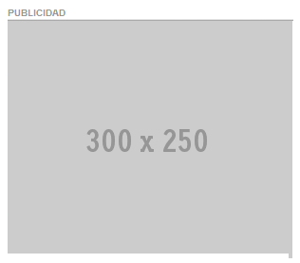
* 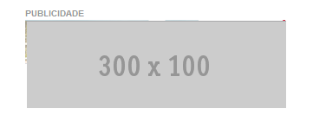

Módulo de compras:

* Muestra los 5 productos más vendidos de libros, revista, cursos  
  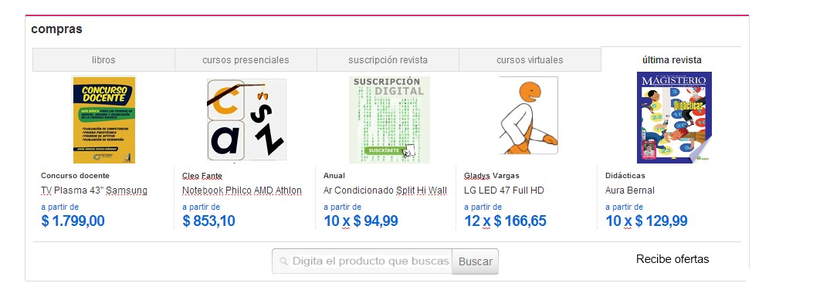

Páginas más leías

* Mostrar los títulos de las 5 páginas más leídas con sus enlaces

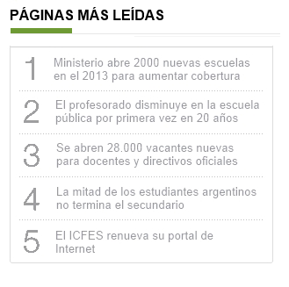

Artículos:

* Mostrar los últimos 4 artículos de lectura publicados
* Mostrar el autor
* La foto destacada
* La etiqueta
* El título

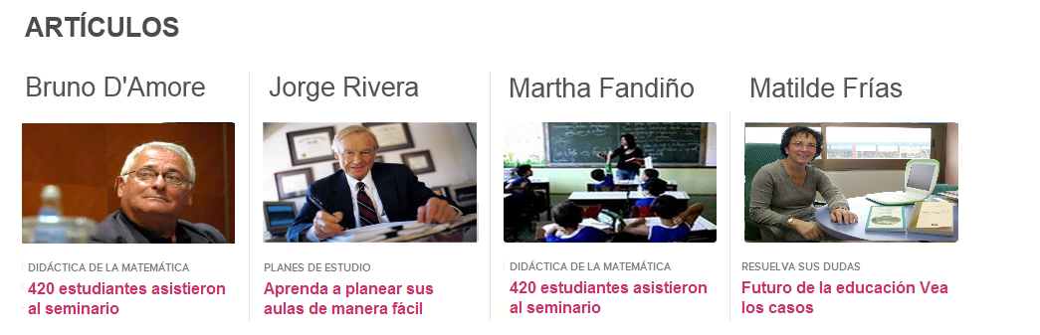

Módulo de vídeos: mostrar videos de nuestro canal de youtube

### Sincronización de INTERFASES

Sincronización automática o por interfases con los ERP’s de la compañía.

## Users

Users with differents permissions and roles: superadministrator, administrator, content generator,

Normal

anexo-31-user-profile  
anexo-32-user-profile-cambiar-contrasena  
anexo-33-user-profile-mis-pedidos  
anexo-34-user-profile-mis-pedidos-ver-pedido  
anexo-35-user-profile-mis-preferencias